New Keynesian Aggregate Supply in the Tropics: Food prices, wages and inflation

Ashima Goyal* and Shruti Tripathi* *
January 31, 2011

Professor*
Research Scholar* *
Indira Gandhi Institute of Development Research
Gen. Vaidya Marg, Santosh Nagar,
Goregaon (E), Mumbai-400 065
Tel.: (022) 28416524, Fax: (022) 28402752
ashima @ igidr.ac.in
www.igidr.ac.in /~ashima

Abstract
Since consumer prices are a weighted average of the prices of domestic and of imported consumption goods, and producer prices feed into final consumer prices, wholesale price inflation should cause consumer price inflation. Moreover, there should exist a long-term equilibrium relationship between consumer and wholesale price inflation and the exchange rate. But if food prices affect wages and wages affect producer prices CPI inflation should Granger cause WPI inflation. This reverse causality is derived from an Indian aggregate supply function. The restrictions on causal relationships are tested using a battery of time series techniques on the indices and their components. Using controls for other variables affecting the indices, we find evidence of reverse causality. Second, both the identity and the AS hold as long-run cointegrating relationships. There is an important role for supply shocks. Food price inflation is cointegrated with manufacturing inflation. The exchange rate affects consumer prices. The insignificance of the demand variable in short-run adjustment indicates an elastic AS. There is no evidence of a structural break in the time series on inflation. Convergence is slow, and this together with differential shocks on the two series may explain their recent persistent divergence.

Keywords: Consumer and wholesale price inflation, aggregate supply, Granger causality, cointegration, VECM.

JEL codes: E31, E12, C32
Acknowledgement: We thank Reshma Aguiar for assistance.

Sakhi saiyan toh khub hi kamat hai
Mhangai dayan khai jath hai

Translated as:

Friend, my man earns a lot
But that witch inflation eats it all

Folk-type song from film “Peepli Live”

1. Introduction
In a period of great inflation volatility, Indian consumer and wholesale price indices have shown divergent trends. Analysis of the relationship between them may be able to shed light on this divergence, and may also, more generally, help to understand and design policy to address the Indian inflationary process. To the extent supply-side issues dominate inflation contractionary demand policies should be used with caution.

The paper first notes the measurement issues peculiar to India, then sets out the identities linking the two index series, before finally deriving the relationship between them from an Indian aggregate supply function. Producer prices feed into final consumer prices, and there are also greater lags in the collection of consumer prices. Moreover consumer prices are a weighted average of the prices of domestic and of imported consumption goods. This suggests that consumer price inflation (CPII) should in time converge to wholesale price inflation (WPII), so that WPII causes CPII. Moreover, there should exist a long-term equilibrium relationship between consumer and wholesale price inflation and the change in exchange rate.

But prices also depend on aggregate demand and supply. If producer prices are set as a mark-up on wage costs, with the mark-up depending on demand pressures, and wages depending on consumer prices, the causality between wholesale and consumer price inflation could be reversed. Now CPII would cause WPII. India’s per capita income is still low, so the share of food in the consumption basket is large. Since nutrition may be necessary for efficiency, average wages may be responding more to the price of food than to the consumer price index (CPI) itself. In that case, even if CPII does not cause WPII, the food component of CPI inflation (CPIIF) may be doing so. We call this reverse causality. The lines of the song the paper starts with, capture the trauma of inflation eating away wages, and therefore, the social pressures that work to restore their real value. The NKE literature has developed and estimated an aggregate supply curve based on optimizing firm behavior subject to different combinations of price and wage rigidities (Woodford, 2003, Gali et. al 2005).

The restrictions on causal relationships suggested by these concepts are tested using time series techniques. We find evidence of reverse causality. CPII and CPIIF Granger cause WPII and WPII manufacturing (WPIIM). Although reverse causality dominates and WPII does not cause CPII, WPI primary articles inflation (WPIIP) causes CPII, reflecting production chain logistics. Second, both the identity and the AS hold as long-run relationships. The exchange rate affects consumer price inflation, and major foodgrain prices are more closely linked to international prices. The insignificance of the demand variable in short-run adjustment indicates an elastic AS. The results imply the price setting process should be taken seriously in the analysis of Indian inflation, and the way firms pass on costs studied. Food price inflation is important for the Indian inflationary process. Short and long-term action on this front is likely to be an effective way to reduce Indian inflation.

The idea of firms setting prices that is a hallmark of the modern New Keynesian (NKE) approach is only beginning to be applied in the analysis of Indian inflation. Monetary policy has been dominated by the monetarist paradigm focusing on the relationship between money supply and prices with an economy assumed to be near full capacity (Nachane and Nadkarni, 1985). But a Structuralist-Keynesian approach has analyzed demand shortfalls in an economy with a large pre-modern sector (Rakshit, 2009). Balakrishna (1994) tests whether the monetarist or structuralist approach to inflation best suits the Indian economy on the basis of encompassing principle, and finds support for the latter. Dua and Gaur (2010), who successfully estimate NKE Phillips curves for eight Asian countries, find the excess demand variable, potential output, is significant but only when supply shock variables such as food production or prices are included. The exchange rate affects inflation, but a money gap, as an excess demand variable, is rarely significant. Both lagged and forward-looking inflation expectations are significant. Goyal (2008) estimates NKE aggregate demand and supply curves for India finding evidence that output was below capacity, and that lagged CPI inflation affects WPI inflation. Generalized method of moments estimation of aggregate supply, using forward-looking variables, finds expected future CPI values significantly affect CPI inflation, but WPI inflation is backward looking.

The relation between CPI and WPI has also been analyzed using time series techniques. Some kind of stable relationship is expected to exist between the two series because of inter-linkages between the wholesale market and the retail market. Samanta and Mitra (1998) applied cointegration and Granger causality tests for two sub periods (i) April 1991 to April 1995 and (ii) May 1995 to 1998. A stable long-run relationship between CPI and WPI existed during 1991 to 1995, but not thereafter. Even the short run relationship changed in the latter period. Shunmugam (2009) examines the time lag with which CPI responds to a change in WPI, the causal relationship between the two series and if they are cointegrated in the long run, over 1982 to 2009, and for pre- and post liberalization periods. He finds long run cointegration, but in the short run they fail to affect each other. These lags have become longer in the post liberalization era, implying worsening structural rigidities.

We extend the two variable tests in the literature by including other important variables affecting WPI and CPI and find evidence of both long and short-run relationships. There is no evidence of a structural break in the time series on inflation, and there is no substantial change in the relationships in sub-periods. The recent divergence between the series is due to differential shocks and slow short and long run convergence. These time series tests on CPI, WPI and their components support the NKE type AS, but in an emerging market supply shocks turn out to be important.

The structure of the paper is as follows: Section 2 explores aspects of the measurement of CPI and WPI in India; Section 3 derives the conceptual relations between the two, which lead to the empirical tests; Section 4 presents the data sources and methodology; Section 5 gives the results, before Section 6 concludes. Some test results are in the Appendix.

2. CPI and WPI: measurement and lags
The wholesale price index (WPI), consumer price index (CPI) and the annual implicit national income deflator are the price measures computed in India. The last is broad-based—it includes services. But it is available only at an annual frequency with a lag of over a year. CPI is available at monthly frequencies, with a two- month lag and is not measured on an all India basis. Moreover, food items and services with administered prices have a large weight in the CPI. Because of information and adjustment lags in the CPI, WPI, that is, domestic or producer prices, are used as the preferred measure for policy purposes.

Table 1: Weights of CPI-IW series for all India level
Group & sub group | Base 1982 | Base 2001
Food, Beverages & Tobacco | 60.15 | 48.46
Fuel & Light | 6.28 | 6.43
Housing | 8.67 | 15.27
Clothing & Footwear | 8.54 | 6.58
Miscellaneous | 16.36 | 23.26

Table 2: Weights of WPI series for all India level
Major Groups | Base 1993-94 | Base 2004-05
Primary Articles | 22.025 | 20
Fuel, Power, Light & Lubricant | 14.226 | 14.9
Manufactured Products | 63.749 | 65

Consumer price indices measure the cost of living as the change in retail prices of selected goods and services on which a homogeneous group of consumers spend the major part of their income. The consumer price index for industrial workers (CPI-IW) is compiled using retail prices collected from 261 markets in 76 centres. The items in the consumption basket in different centres vary from 120 to 160. Since January 2006, the revised CPI-IW series on the new base-period of 2001 gives a higher weight to services. Table 1 shows the weight of the six main commodity groups in the CPI-IW series.

While centre specific CPI is aggregated to get the all-India index, WPI is computed on an all-India basis. The commodity coverage in WPI is also wider than that in CPI. The WPI is a Laspeyre’s index (current prices divided by base-year prices with base-year wholesale market transactions as fixed weights). The 1993-94 WPI series had 444 commodities in its commodity basket. Table 2 gives the broad weighting structure. It was available weekly with a lag of only two weeks for provisional index and ten weeks for the final index. Since there are problems in getting weekly data from firms, it is available only at a monthly frequency from 2009, while primary articles continue to be reported at weekly frequency. It did not cover non-commodity producing sectors like services and other non-tradable goods. It has been revised with base 2004-05 from 2010, with the unorganized manufacturing sector, which contributes about 35 percent of the total manufactured sector output, given expanded representation, and the items covered sharply increased to 1230.

WPI inflation averaged at around 5 percent per annum after 2000, only the component ‘Fuel, Power, Light and Lubricant (FPL&L)’ had an inflation rate of 10 per annum from 2000 to 2007, showing higher pass-through of international oil prices to domestic inflation since oil prices were partially de-administered. FPL&L inflation was the key driver of headline inflation after 2000.

CPI-IW inflation averaged around 7.67 percent from 1980 to 2009 (December). It decelerated after 2000, coming down from 8.6 percent in late 1990s to 4.4 percent in the period 2000 to 2005, but rose again to above 7 percent. It was very volatile (as measured by coefficient of variation), except for a brief period in the early nineties, with volatility exceeding that of WPI inflation (Table 3 and 4). Since food group inflation has the highest weight in the CPI-IW inflation basket, its high volatility drove that of CPI-IW inflation.

Table 3: Comparing CPI-IW and WPI Inflation
 | 1981-1990 | 1990-2000 | 2000-2007 | 2007-2010
WPI Inflation
Mean | 6.52 | 8.12 | 5.13 | 5.19
Standard Deviation | 1.36 | 3.57 | 1.41 | 3.92
Coefficient of Variation | 20.85 | 43.90 | 27.58 | 75.52
CPI-IW Inflation
Mean | 7.70 | 9.52 | 4.42 | 8.63
Standard Deviation | 2.62 | 3.01 | 1.08 | 2.44
Coefficient of Variation | 34.06 | 31.63 | 24.56 | 28.27
Source: Updated from RBI (2010) and Goyal (2010)

Table 4: CPI-IW: Descriptive Statistics
 | 1981-85 | 1985-90 | 1990-95 | 1995-2000 | 2000-2005 | 2005-10
CPI-IW inflation: Total
Mean | 7.39 | 7.96 | 10.44 | 8.60 | 4.42 | 7.72
Max. | 12.47 | 9.40 | 13.47 | 13.11 | 6.83 | 16.03
Min. | 3.01 | 6.13 | 7.50 | 3.38 | 3.73 | 3.32
Standard Deviation | 3.93 | 1.42 | 2.23 | 3.65 | 1.08 | 3.03
Coefficient of Variation | 53.21 | 17.79 | 21.39 | 42.40 | 24.56 | 39.25
CPI-IW inflation: Food
Mean | 8.56 | 7.76 | 11.46 | 8.08 | 3.72 | 9.98
Max. | 13.60 | 11.18 | 15.58 | 14.69 | 9.11 | 21.03
Min. | 4.27 | 4.73 | 7.09 | 0.22 | 1.57 | 1.58
Standard Deviation | 4.01 | 2.95 | 3.09 | 5.56 | 2.54 | 4.12
Coefficient of Variation | 46.91 | 37.96 | 26.96 | 68.80 | 68.20 | 41.28
Source: Updated from RBI (2010) and Goyal (2010)
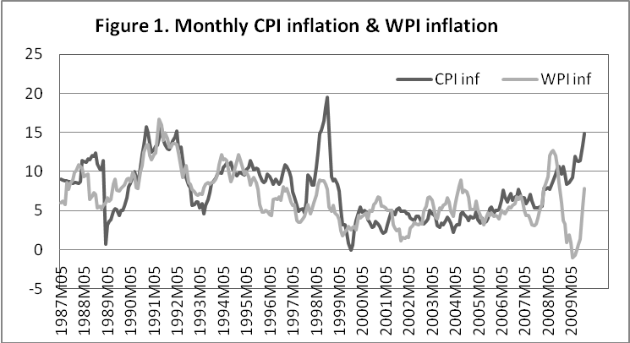

Figure.1 maps monthly WPI inflation (WPII) and CPI-IW inflation (CPII) for the period May 1987 to December 2009. WPII, all commodities (AC), was more volatile in the period of oil price shocks and CPII in the period of food price shocks. The WPI inflation peaks coincided with rise in oil prices. In the late nineties, CPI inflation fell as food prices approached falling world prices and buffer stocks were large. Although there was a steep rise in international food prices from 2007, the pass through to domestic food prices was restricted but it was also prolonged. Indian food inflation continued high even as world food prices fell. The cost shocks have dominated Indian inflation in this later period.

International crude oil price shocks, which drove WPI inflation, have a lower weight in the CPI-IW basket than in the WPI basket. The administered price component in WPI, FPLL, is only 14 percent, and part of it is market determined after the APM was dismantled in 2002. Petrol prices were also tentatively freed in 2010. Part of food items, weight 15.4 percent, is also administered. In the CPI-IW food has a weight of 46.2 percent, fuel and light 6.43 percent and the services component (weight 23.3 percent) also has items with fixed user charges. Therefore the upper limit of components subject to price intervention in WPI is about 30 percent compared to 60 percent for CPI-IW.

The divergence in the series arises partly from the differential impact on each of the two types of shocks. The alternative inflation series do, however, tend to converge over long periods of time, as administered prices are changed, and CPI affects wages which raise costs for producers.

The relationship between components graphed in Figures 2-5 also brings out the importance of food prices, and their effect on manufacturing prices. CPII follows WPI inflation for primary articles (WPIIP) very closely, as is to be expected given the large weight of primary articles in CPI (Figure 2). Although a sustained rise in WPI fuel inflation raises CPI inflation, the shocks are independent (Figure 3). The comparison of WPI manufacturing inflation (WPIIM) with CPII (Figure 4) and CPI food inflation (CPIIF) (Figure 5) suggests the latter has a lead relationship with WPIIM. A sustained period of higher CPI food inflation generally leads to a rise in WPIIM inflation. However, we need formal tests to validate these visual impressions.

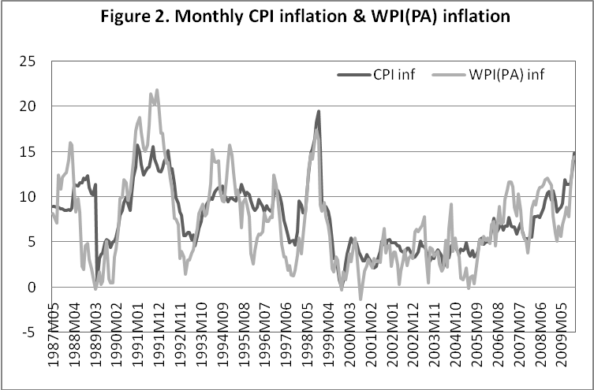
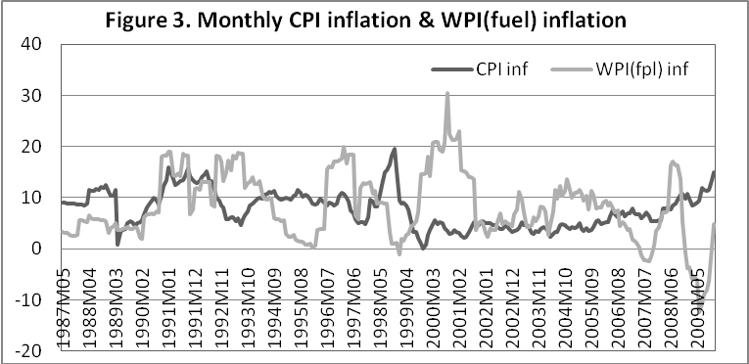

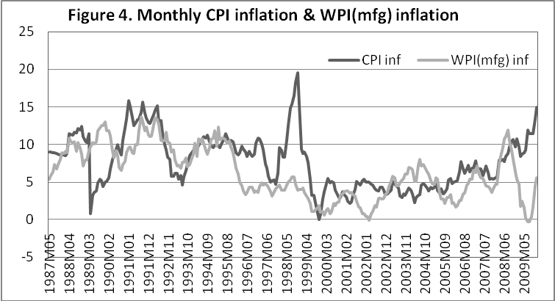

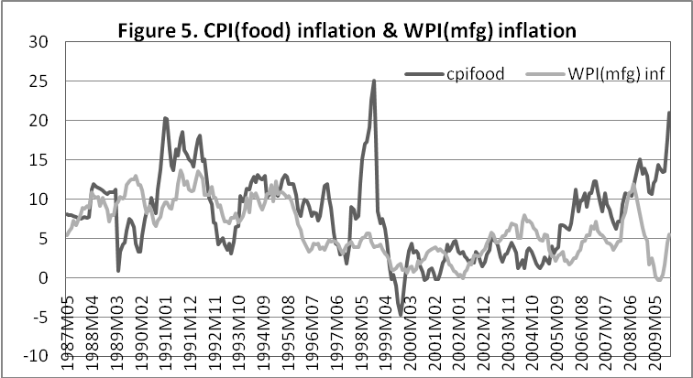

3. CPI and WPI: Deriving tests

3.1 Identities
If WPI or domestic prices are P_{H}, WPI inflation written in logs is$π_{H, t}≡p_{H, t+1}−p_{H, t}$. CPI, p_{t}, is a weighted average of domestic prices and foreign prices, where the latter are multiplied by the index of openness α. So CPI can be log-linearized:
$p_{t}=\left(1−α\right)p_{H, t}+{αp}_{F, t}$ (1)
The log price of foreign goods p_{F,t} is:
$p_{F, t}=e_{t}+p_{t}^{}$ (2)
Where ε_{t} is the nominal exchange rate, e_{t} its log value; $P_{t}^{}$ is a world price index and $p_{t}^{}$ its log value. Thus we see the relationship between WPI, CPI and the nominal exchange rate. The nominal exchange rate e_{t} is measured in units of foreign currency so that a rise implies a depreciation of the home currency. The effective real exchange rate is:
$Z_{t}≡\frac{ε_{t}P_{t}^{}}{P_{t}}$ (3)
From (3) the log effective real exchange rate can be written:
$z_{t}=e_{t}+p_{t}^{}−p_{t}$ (4)

3.2 Aggregate Supply
India is a populous country with more than two-thirds of the population still rural, so this dualistic labour market affects aggregate supply. As in the New Keynesian approach, aggregate supply can be derived from a microfoundation of imperfectly competitive price-setting firms. This gives a traditional Phillips curve linking prices to wage costs, but with forward-looking variables, like expected inflation. Woodford (2003) does this derivation for different kinds of wage and price rigidity. In the Indian context, the link from food prices to wages can be expected to be important, and the degree of forward looking behaviour reduced. Empirical implementations of the New Keynesian aggregate supply have also had to introduce lagged inflation to improve estimations (Gali et. al 2005).

In a dualistic labor market even if wages are not formally indexed to prices, the low wage level is highly sensitive to food prices. In classical dual economy models (Lewis, 1954) surplus labour kept real wages constant at subsistence, as labor and food transferred from agriculture to industry. But in economies with large reserves of labour employed at low productivity the average household spends the major share of its budget on food. A rise in the price of food can lower real wages below the efficient level determined by nutritional requirements. Employers would then raise the nominal wage. Or Government interventions such as MGNREGA (a rural employment guarantee scheme) raise the minimum wage. The socially acceptable real wage can itself rise, as a more diversified consumption basket becomes the norm. This is a good thing. But a rise in nominal wages raises costs and prices. So complementary policies that raise agricultural productivity and keep food prices low are required for wages to rise without adverse effects on inflation. Then the average real wage rate can rise even in countries far from having absorbed labor in higher productivity occupations and achieved the transition to a developed economy.

If food budget shares are high, labor productivity determines the agricultural terms of trade that are consistent with the acceptable real wage. If productivity is low this value may lie below the level at which relative prices would clear markets. Then there would be a tendency for nominal wages to rise. Any rise in food prices would raise wages and the general price level. If political pressures prevent a fall in agricultural terms of trade, and real wages also do not adjust, an inflationary wage price cycle results. Agricultural labor productivity must rise for a non-inflationary rise in real wages to be possible.

Although Asian countries were typical labour surplus countries all of them realized the importance of rising agricultural productivity. East Asian countries were successful developers in the sixties and seventies. They were careful to moderate food price increases and focus on a rise in agricultural productivity as long as food budget shares were high. Only after that were food prices and the nominal rate of protection in agriculture allowed to rise. In Japan, food budget shares fell below fifty per cent in the post war period, and in Taiwan and Korea in the sixties. In Korea, expenditure on food as a percentage of total expenditure of urban households was 45 per cent in 1960. Over 1989-91 the average cereal yield (kg per ha) in East and Southeast Asia, 3.817, exceeded that in North America. But in South Asia it was only 1.919.

Since there is no cost of living indexation in the large informal Indian labor market (accounting for 80 percent of the work force) nominal wage adjustment is lagged. But as inflation becomes more forward looking the lag can be expected to fall. There are political pressures to raise nominal wages in response to a rise in food prices, as well as pressures from well-organized farm lobbies (the share of the rural population still exceeds 70 percent) for high and rising farm support prices. The compromise has been to raise support prices but subsidize consumers through a low price public distribution system. Since the latter is not very effective, protection is partial, and nominal wages rise with a lag in response to a rise in food prices.

To model such a structure, assume producer prices are marked up on wages, so producer price inflation responds to nominal wage inflation, lagged output y_{t} (mark-ups may rise with demand pressures or fall as better capacity utilization spreads costs) and contemporaneous oil (η_{t+1}) or productivity (g_{t+1}) shocks to supply:
$p_{H,t+1}−p_{H,t}=\left(w_{t+1}−w_{t}\right)+{ψy}_{t}−g_{t+1}+η_{t+1}$ (5)
If employers want to pay nutrition-based wages in the medium-term, this leads to a real wage target in terms of food prices:
$\bar{w}=\frac{W_{t}}{P_{t}^{F}}$ (6)
Nominal wages respond to lagged food prices, or consumer prices which have a large weight of food prices, so, w_{t} changes with $p_{t−1}$. Substituting out wages from equation (5) gives:
$p_{H,t+1}−p_{t}=\left(p_{t}−p_{t−1}\right)+{ψy}_{t}+η_{t+1}−g_{t+1}$ (7)
With trade liberalization food prices become more closely linked to border prices and given the large weight of food in the CPI, the effect of e_{t} on CPI (Equation 1) rises; $p_{t}$ responds to e_{t}; wages respond to p_{t}; and producer prices are marked up on wages. Writing aggregate supply in terms of inflation, we get:

$π_{H,t+1}=π_{t}+{ψy}_{t}+η_{t+1}−g_{t+1}$ (8)

If wages are set in a forward looking fashion so w_{t} changes with expectations of p_{t+1}, aggregate supply can be written as:
$π_{H,t}={βE}_{t}\left\{π_{ t+1}\right\}+{ψy}_{t}+η_{t+1}−g_{t+1}$ (9)

Aggregate demand determines the output gap, which responds positively to the real exchange rate and negatively to the real interest rate. All variables are expressed as log-linearized deviations from a mean.
$y_{t}=δ z_{t}−σ\left(i_{t}−\left(p_{t+1}^{e}−p_{t}\right)\right)$ (10)
Expected inflation $\left(p_{t+1}^{e}−p_{t}\right)$ subtracted from the nominal interest rate gives the real interest rate in the second bracket of equation (10).

3.3 Tests
These conceptual derivations suggest testing for:
- The direction of causality between wholesale price inflation and consumer price inflation, and their components.
- A long-term equilibrium relationship between consumer and wholesale price inflation and the exchange rate, and between the variables entering aggregate supply.
- The speed of adjustment.

4. Data and methodology
Data set included: Index of industrial production, IIP, CPI (general index) for industrial workers, WPI (all commodities), call money rate, INR/USD exchange rate, CPI (food), WPI (manufactured Goods), WPI (fuel petroleum and lubricants), WPI (primary products) and international oil prices from 1986M4 to 2009M1 2. oil prices were taken as USD spot price of WTI light crude as traded on NYMEX for delivery at Cushings, Oklahoma. Since the data set was monthly seasonality was expected. Hence all the series were seasonally adjusted using ARIMA X 12. The major data source was the RBI website; oil prices were taken from International Foreign Statistics (IFS).

All the indices and oil prices were first transformed into logs and then year on year inflation, growth rate, or depreciation respectively calculated. Exchange rate depreciation and CMR change are in percentage terms. The table below links the base periods for which series were available. Linking factors were taken from the Ministry of Statistics and Programme Implementation (MOSPI) website

INDEX | Base Year Available
CPI(general index), CPI (food) | 1982, 2001
WPI (all commodities), WPI (primary articles), WPI (fuel), WPI (manufactured goods) | 1981-82, 1993-94
IIP (general index) | 1981-82, 1993-94

The base period 1982 was chosen since it was common among all the series, also because 1982 was the base of CPI for the majority of the time period. The CPI base is more difficult to change, because of the problems in estimating the index. However, the tests were all repeated by converting to base 1993-94 also.

When adjusted for seasonality and then checked for stationarity all the variables except for call money rate and IIP growth come out to be I (1) variables. The Zivot-Andrews test showed the absence of a structural break, confirming plots of the indices, which also did not show a break (Appendix).

Granger Causality Tests
Granger causality is a statistical measure of causality. One time series is said to Granger cause another if the past values of the first improve the forecasts of the other. Using both series together gives a better prediction than using only the past values of the second series. X does not granger cause Y (X~GC Y) if prediction of Y based on universe U of predictors is not better than prediction based on U-{X} i.e. on the universe with X omitted. This is a much stiffer test than just a contemporaneous correlation between variables. We use a systems approach to test lead-lag dynamics that improves the power of statistical tests since it takes into account contemporaneous correlation of model residuals across variables.

Each VAR system estimated relates inflation based on one price index to lagged values of itself and lagged values of inflation based on another price index or vice versa. Granger causality is also tested between various sub-components of the indices. For example, it is tested if CPI food inflation Granger causes WPI manufacturing inflation. But bi-variate Granger causality has to be taken with caution since it is possible, for example, that CPI inflation is correlated with some third variable that is actually causing WPI inflation to rise. Therefore we use control variables. This is an innovation in this paper.

Granger Causality Tests with Controls
The causality analysis is also done including variables that provide information on the overall state of the economy. Specifically, the IIP index (as a proxy for output), the call money rate, and exchange rate, and log oil prices are the other variables apart from prices that enter our aggregate demand and supply equations. Since these variables are related in different ways to both producer and consumer price inflation, including them helps identify pass-through effects that might otherwise be obscured, and ensures that the causality tests are not picking up effects due to omitted relevant variables. For example, in VAR we will have an equation that gives the relation between the current quarter’s rate of CPI inflation and lagged values of CPI and WPI inflation, IIP growth, the call money market rate, and exchange rate depreciation. Other equations in the VAR model relate current values of WPI inflation to lagged values of all variables in the model. The control variables were tested for block exogeniety. But since that was rejected for one variable, all the variables were treated as endogenous in the estimation. A separate VAR system was estimated for testing Granger causality of each of the sub-indices tested. We follow procedures suggested in Lütkepohl (2004) to ensure the Wald statistic for zero restrictions has its usual limiting Chi-squared distribution when testing for Granger causality in a multivariate system where the VAR contains I (1) variables, such as our test of (X~GC Y) conditional on Z. Overfitting the VAR order and ignoring the extra parameters can overcome singularity in the asymptotic distribution.

Impulse Response
The impulse response functions identify the effects of an unanticipated one-percentage point temporary increase in the growth of one variable on other variables in the system, and therefore offer a measure of convergence across the price indices. These are estimated with the VAR systems used in the GC analysis.

Forecasting Efficiency
If, for example, the production lags imply WPII leads CPII, then WPII should be useful for forecasting CPII out of sample. And vice versa for reverse causality. GC also implies the model that includes WPII should predict future CPII better than the model that excludes the WPI. Therefore, examining whether the WPII helps forecast CPII, illustrates GC and supplements evidence provided by the in-sample test. Even if this does not hold for the aggregate indices, since of reverse causality, we would expect WPIIP to affect CPI inflation.

So we compare forecasts from a model that includes CPI inflation as the only measure of inflation with forecasts from a model that includes both CPI and WPI inflation in the presence of call money rate, exchange rate appreciation/depreciation, and IIP growth rate.

Forecasts of CPI inflation are computed from 2008M1 to 2009M12 using the two models and data beginning in 1987M4. For the first month of 2008, the models are estimated using data from 1987M4 to 2007M12, and inflation is forecast for the first month of 2008.Then, for the second month of 2008, the models are re-estimated using data from 1987M4 to 2008M1, and inflation is forecast for the second month of 2008, and so on. The forecasting performance of the models is evaluated using the average absolute error, or gap between the forecast and actual rates of inflation.

Cointegration and Vector Error Correction Models (VECM)
The theoretical relationships we derived imply specific long-run relationships between these time series, so that a linear combination of the variables must be stationary. This is the definition of cointegration, which implies a common stochastic trend. So for any one variable changes persist with no tendency to come back to a normal path, but a linear combination of the series exists giving an equilibrium or stationary relationship. A shock to anyone or more than one series gets absorbed by the system as a whole and the entire system moves from one equilibrium point to other. A precondition for testing cointegration is the series must be I (1). All the variables, except for CMR, were I (1) at levels (see Appendix). So we checked for cointegrating relationships between them, excluding CMR.

We found two cointegrating vectors, corresponding to the two theoretical relationships. If variables are cointegrated then VECM is used to model the long run together with short run adjustment. Moreover, Granger causality implies restrictions on the coefficients of the VECM model, which we also test for.

5. Results
The various types of tests provide consistent evidence that increases in food prices are followed by higher WPI inflation. Results from the Granger Causality, VECM and forecasting efficiency all support the AS with cost-push from food prices. They also support the CPI identity, with exchange rate depreciation raising consumer prices.

Granger Causality
Table 5 gives the results:
- WPI inflation (primary articles) Granger causes CPI (all commodities) inflation.
- CPI (all commodities) inflation Granger causes WPI (general) inflation.
- CPI inflation (food) Granger causes WPI (general) inflation
- CPI (all commodities) inflation Granger causes WPI (manufactured goods) at 10% significance level.
- CPI inflation (food) Granger causes WPI (manufactured goods) inflation.
- WPI (fuel) inflation Granger causes WPI (manufactured goods) inflation.
- Exchange rate change Granger causes CPI food inflation.

Table 5: Granger Causality Results with Controls
Model number | Wald Test null hypothesis | Chi square value (p value)
1.A | CPII do not GC WPII | 19.8 (0.00)
1.B | WPII do not GC CPII | 3.6 (0.16)
2.A | CPII do not GC WPIIM | 14.9 (0.00)
2.B | WPIIM do not GC CPII | 4.1 (0.13)
3.A | CPII do not GC WPIIP | 3.1 (0.21)
3.B | WPIIP do not GC CPII | 45.6 (0.00)
4.A | CPIIF do not GC WPIIM | 14.9 (0.01)
4.B | WPIIM do not GC CPIIF | 4.4 (0.36)
5.A | CPIIF do not GC WPII | 11.7 (0.02)
5.B | WPII do not GC CPIIF | 4.3 (0.12)
6.A | WPIIF do not GC WPIIM | 10.2 (0.01)
6.B | WPIIM do not GC WPIIF | 2.4 (0.31)
7.A | ERD do not GC CPIIF | 4.8 (0.03)
7.B | CPIIF do not GC ERD | 2.8 (0.25)
Definitions of abbreviations are given in Table A1

The tests without the control variables, reported in the Appendix, give similar results. Except that there is bi-variate causality between WPI inflation and CPI inflation, and WPI inflation Granger causes CPI food inflation. The controls show the AS causality or influence of CPII and CPIIF on WPII to be more robust. This causality is also supported by the effect of CPI and CPIF on WPIM directly. The results are also robust since they largely held for different bases and sub-periods.

Forecasting Efficiency
The implications of Granger causality for forecasts are validated.

Table 6: One-Month-Ahead Average Absolute Forecast Errors
Sample Period | Model with CPII only | Model with both CPII and WPIP
2008M1-2009M12 | 1.25 | 0.88
 | Model with WPIM only | Model with both WPIM and CPIF
2008M1- 2009M12 | 0.84 | 0.68
 | Model with WPII only | Model with both WPII and CPII
2008M1- 2009M12 | 1.13 | 0.98

Results:
1. Inclusion of WPIIP in a model to forecast CPII reduces forecast error, which implies a model that includes both CPII and WPIIP is a better model, and using WPIIP information improves forecasts of CPI inflation.
2. Inclusion of CPII food in a model to forecast WPII manufacturing reduces forecast error, which implies model that includes both CPIIF and WPIIM, is a better model
3. Inclusion of CPII in a model to forecast WPII reduces forecast error, which implies model that includes both CPII and WPII is a better model.

Vector error correction model (VECM)
Johansen cointegration test was conducted for the I (1) variables WPI inflation (all commodities), CPI inflation (general), IIP in levels, change in oil prices (USD) and exchange rate depreciation, leaving out CMR since it was I (0). The test shows there exist two cointegrating relationships among these variables (Appendix). So the model can be formulated in error correction form. We fit VECM with 2 lags.

VECM models distinguish between stationary variables with transitory (temporary) effects and nonstationary variables with permanent (persistent) effects. While the dynamics part of the model describes the short run effects, the cointegrating relation describes the long run relation between the variables. The VECM (p) is written as:

Where X_{t} is vector of variables, and ПX_{t-1} gives the error correction term
When cointegrating relationships r = 2, ПX_{t-1} is given as,

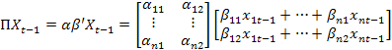

Since our X_{t} is a (5×1) vector of I (1) variables β is a nonzero (5×2) cointegration matrix. The vector of cointegrating relationships β’X_{t} (2×1) is stationary. Each cointegrating relationship is denoted as ect. The (5×2) matrix α contains the weights attached to the cointegrating relationships in the final model vector ПX_{t-1} (2×1). It is also sometimes called the loading matrix.

We test for the hypothesis whether AS relationship (as given by equation 7) and/or identity for CPI hold. The LR test statistic, following chi-square distribution with 2 degrees of freedom, for joint hypothesis testing was given as 2.206 and p-value is 0.137. So both hypotheses are accepted implying these relationships are long run equilibrating relationships.

Beta (1) vector gives AS relationship and Beta (2) vector gives the CPI identity. When we normalize the first vector by WPI and the second vector by CPI, we get, the (2×5) β’ matrix. The two long run equilibrating relationship can be written as:

$${\text{WPII}}_{t−1}−1\text{.}\text{438}{\text{CPII}}_{t−1}−0\text{.}\text{25}{\text{IIP}}_{t−1}−1\text{.}\text{540}{\text{OIL}}_{t−1}−0\text{.}\text{705}{\text{ERD}}_{t−1}$$

The first implies that WPII rises with CPII, IIP, oil shocks and ERD although ERD is not significant. The second implies that CPII is the sum of WPII and exchange rate depreciation. The series resulting from these two relationships would be stationary series.

We tested for the hypothesis that coefficients in the loading matrix α₁₂, α₂₁, which were insignificant, were equal to zero, that is, α₁₂, = α₂₁ = 0. For this hypothesis the null was accepted, chi square value was 4.911 with p-value as 0.178. Thus for CPII equation only the first relationship of the CPI identity was significant, while for WPII the cointegrating equation derived from AS equation was significant. The estimated VECM equations for only the CPII and WPII variable are written in matrix form below, with t-values in brackets.
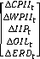
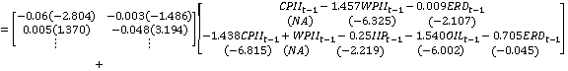
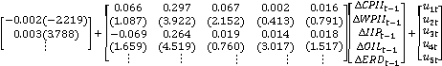

The strongly significant loading coefficients imply the cointegration relations are important in the adjustment for each equation, but the low values imply adjustment to long-run equilibrium is slow. Diagnostic checks, on correct choice of cointegrating rank, misspecification tests of residuals, parameter constancy etc., support the adequacy of the model.

The error correction term is significant and correctly signed. However, the value of the coefficients on lagged CPI and WPI inflation in their respective equations imply inertia in the inflation process. The low cross equation coefficients imply slow convergence of the two series to each other. While ∆OIL and ∆ERD is not significant in short run for ∆CPII, for ∆WPII IIP growth is not significant in the short-run while ∆OIL is strongly significant and ∆ERD is weakly significant.

The VECM results are consistent with bi-directional Granger causality since each index significantly enters the equation of the other, but the effect of WPII on CPII is stronger than vice-versa. While the coefficient of ∆WPII_{t-1} is strongly significant in the ∆CPII_{t} equation, the coefficient of ∆CPII_{t-1} in ∆WPII_{t} equation is weakly significant at ten percent. The VECM VAR model is not strictly equivalent to the VAR used in the GC analysis since the interest rate variable CMR is missing in the VECM. We also did the exercise replacing CPII with CPIIF, and WPII with WPIIM. There was one cointegrating relationship supporting the AS showing the direct effect of food prices on price setting in manufacturing:

It is also interesting that WPIIM falls with IIP_{t-1} suggesting scale effects may be decreasing inflation as output rises. The VECM representation was:

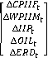

The loading coefficient is significant only for ∆WPIIM_{t-1}, for which the cointegration vector applies. Own lags are dominant in the short-run dynamics, but ∆ERD is significant for ∆CPIIF and oil for ∆WPIIM. Lagged VECM coefficients give the short-term response. The CPI identity was not supported for CPIF, but Rahman (2010) found cointegration between domestic and international wheat and rice prices, although adjustment coefficients were low. A possible explanation is, although tariff barriers continued in agricultural trade, international prices influenced government intervention in the major foodgrains. Calculations with data from the CACP (2010, Table 2.28, pp.488) show that unit value of export of wheat exceeded minimum support price by an average Rs 206.2 per quintal in the nineties, but over 2001-04 the value was negative –88.6, and over 2004-08 positive again but much lower than the nineties at 91.7. Thus in this decade support prices were raised much more in synch with international prices, but did not fall as much as international prices did.

Impulse Response
Impulse responses to shocks in the VAR system give the long-term accumulated elasticity of WPI inflation and WPI manufacturing inflation. Long-term is defined as time horizon over which the effects on the other variables of innovations in CPII and CPIF disappear (in their respective models). In our analysis, this horizon is 10 months. The long-term elasticity is obtained by allowing all variables to respond to the shock to CPII in the first step. It measures the long-term cumulative effect of CPII on WPII at the last step.

The term elasticity used here differs from the conventional notion. The latter is based on ceteris paribus assumptions whereas impulse response gives the total effects of a shock from the whole array of dynamic interactions among variables.

The VARs estimated for Granger causality were used to obtain the impulse responses. These include CMR, which the VECM leaves out. VAR results depend on the ordering of the variables. IIP growth, CMR and ERD were weakly exogenous and Granger causality results showed that CPI inflation Granger causes WPI inflation and CPI food inflation granger causes WPI manufacturing inflation. Therefore, the Cholesky ordering selected was CMR, IIP, ERD, CPII and WPII and the last two terms were replaced by CPIF and WPIM in case of the second model. The response of the policy variables was assumed to occur with a lag.

Table 7: Accumulated responses of Impulse Responses
Period | WPII due to shock in CPII | WPIM due to shock in CPIF
1 | 0.150 | 0.000
2 | 0.144 | 0.194
3 | 0.177 | 0.199
4 | 0.177 | 0.202
5 | 0.185 | 0.215
6 | 0.184 | 0.218
7 | 0.184 | 0.222
8 | 0.182 | 0.217
9 | 0.181 | 0.214
10 | 0.179 | 0.212

A one percent change in CPII in period one brought about a cumulative 0.179 percent change in WPII at the end of tenth period (month). A one percent change in CPIIF in period one brought about 0.212 percent change in WPIIM at the end of tenth period. Results indicate persistent and repeated rises in CPIIF can have a large cumulative effect on WPIIF, but the differential shocks also explain the large divergence between the two series in recent years.

6. Conclusion
Since consumer prices are a weighted average of the prices of domestic and of imported consumption goods, and producer prices feed into final consumer prices, wholesale price inflation should cause consumer price inflation. Moreover, there should exist a long-term equilibrium relationship between consumer and wholesale price inflation and the exchange rate. But we derive a second relation between the series from an Indian aggregate supply function. This suggests the CPI inflation should Granger cause WPI inflation, through the effect of food prices on wages and producer prices.
These restrictions on causal relationships are tested using a battery of time series techniques, on the indices and their components. We find stronger evidence of reverse causality, that is, food price inflation Granger causes wholesale price inflation, when controls are used for other variables affecting the indices. All the variables entering aggregate supply are included in the estimated VAR system. CPI and CPI food inflation both Granger cause WPI and WPI manufacturing inflation. But the effect of lags in the retailing system is captured in WPI primary goods inflation Granger causing CPI food inflation. That exchange rate depreciation Granger causes CPI food inflation supports the identity. There is evidence of a closer link between domestic and international prices in the major foodgrains.

Second, both the identity and the AS hold as long-run cointegrating relationships. There is an important role for supply shocks. Food price inflation is also cointegrated with manufacturing inflation. The insignificance of the demand variable in short-run adjustment indicates an elastic AS. There is no evidence of a structural break in the time series on inflation. Long and short-run convergence is slow, and this together with differential shocks on the two series may explain their recent persistent divergence. Reform has barely touched the deeper structural factors affecting the Indian inflationary process.

References
Balakrishna, P. 1994. ‘How Best to Model Inflation in India’, Journal of Policy Modeling, pp. 677-83, December.
CACP (Commission for Agricultural Costs and Prices). 2010. Reports of the CACP. Commission for Agricultural Costs and Prices. Department of Agriculture and Cooperation. Ministry of Agriculture. Government of India. New Delhi.
Dua, P. and Gaur, U. 2010. ‘Open Economy Phillips Curve in Developed and Developing Asian Countries’, Macroeconomics and Finance in Emerging Market Economies, 3 (1): 33 – 51.
Engle, R. F. and Granger, C. W. J. 1987. ‘Co-integration and error-correction: Representation, estimation and testing’. Econometrica 55: 251—276
Gali, J., M. Gertler and J. D. López-Salido. 2005. ‘Robustness of the Estimates of the Hybrid New Keynesian Phillips Curve’. Journal of Monetary Economics 52: 1107-118.
Goyal, A. 2010. 'The Structure of Inflation, Information and Labour Markets: Implications for monetary policy', in P. Agrawal, B. Goldar and P. Nayak (eds.), India's Economy an d Growth: Essays in Honour of V.K.R.V. Rao, New Delhi: Sage.
--- 2008. 'Incentives from Exchange Rate Regimes in an Institutional Context', Journal of Quantitative Economics, January & July, 6:1&2, 101-121
--- 2003. 'Agriculture and Industry: Enhancing mutual gains', Decision, July-December, Vol. 30, No. 2.
Granger, C. W. J. 1969. ‘Investigating Causal Relations by Econometric Models and Cross-spectral Methods’. Econometrica 37: 424-438.
Lewis, A. 1954. ‘Economic Development with Unlimited Supplies of Labour’, The Manchester School, 28, 139-91.
Lütkepohl, H. 2004. ‘Vector Autoregressive and Vector Error Correction Models’. Chapter 3 in Applied Time Series Econometrics. Helmut Lütkepohl and Markus Krätzig (eds). Cambridge University Press.
Mahendra Dev, S., and Rao N. C. 2010. ‘Agricultural Price Policy, Farm Profitability and Food Security: An Analysis of rice and Wheat’. Mimeo.
Nachane, D.M. and Nadkarni, R.M. 1985, ‘Empirical Tests of Certain Monetarist Propositions via Causality Theory’. Indian Economic Journal, 33:139-155.
Rahman, A. 2010. ‘Transmission of World Food Inflation on Food Inflation in India’. Term Paper, International Finance and Economics Course, IGIDR.
Rakshit, M. 2009. ‘Macroeconomics of Post-reform India’. Vol. 1. New Delhi: OUP.
Samanta, G. and Mitra, S. 1998. ‘Recent Divergence between Wholesale and Consumer Prices in India- A statistical exploration’. RBI occasional papers, Vol. 19,
Shunmugam, V. 2009. ‘Causality links between CPI and WPI- An econometric exploration’. Mimeo.
Woodford, M. 2003. ‘Interest and Prices: Foundations of a Theory of Monetary Policy’. NJ: Princeton University Press.
Zivot, E. and Andrews, D. W. K. 1992. ‘Further Evidence on the Great Crash, the Oil-Price Shock, and the Unit-Root Hypothesis’. Journal of Business & Economic Statistics, American Statistical Association, vol. 10(3), pages 251-70, July.

Appendix

Table A1: Unit Root Testing
 | Test Statistic (p-value) | First diff
CPI inflation (CPII) | -2.358 (0.1538) | -8.954 (0.0000)
CPI (food) inflation (CPIIF) | -2.172 (0.2165) | -3.093 (0.0271)
WPI (general) inflation (WPII) | -2.480 (0.1204) | -3.307(0.0146)
WPI (primary good) inflation (WPIIP) | -3.447 (0.0095)
WPI (FP&L) inflation (WPIIF) | -3.401 (0.0109)
WPI (manufacturing) inflation (WPIIM) | --2.013 (0.2807)
Call money rate (CMR) | -5.964 (0.0000)
Exchange rate depreciation (ERD) | -2.722 (0.0817) | -3.218 (0.0190)
IIP growth (IIPG) | -6.755 (0.0000)

Zivot Andrews test for structural break:

Table A2. Zivot-Andrews test
Variable | Value
CPI | -0.145
CPI (food) | 0.051
WPI | -3.681
WPI (primary article) | -2.172
WPI (FP&L) | -3.805
WPI (manufactured good) | -3.745
Exchange Rate | -2.919
IIP | -2.812
Critical value: 5%= -4.80, 10% = -5.43

A problem with conventional unit root tests is they do not allow for the possibility of a structural break. The power to reject a unit root decreases when the stationary alternative is true but a structural break is making the series diverge. Zivot and Andrews (1992), argued that selecting the structural break a priori based on an ex post examination or knowledge of the data could lead to an over rejection of the unit root hypothesis. We follow Zivot-Andrews to test the null of unit root against the alternative of stationary caused by endogenous breaks in the data series

We do not find any structural break in the data, which is in conformity with original plots of the data series.

Figure A1: Plots of CPI
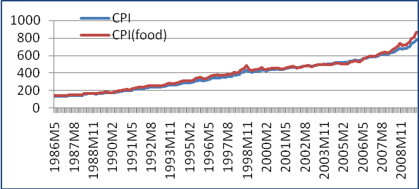

Figure A2: Plots of WPI
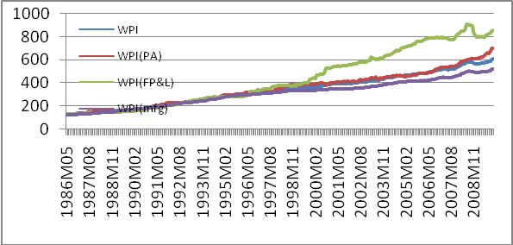

Table A3: Lag Selection Criteria Based on SBIC for VAR Modeling
Model number | Variables | Lag length for VAR model
1. | CPII, WPII, ERD, IIPG, CMR | 3
2. | CPII, WPIM, ERD, IIPG, CMR | 2
3. | CPII, WPIP, ERD, IIPG, CMR | 3
4. | CPIF, WPIM, ERD, IIPG, CMR | 2
5. | CPIF, WPII, ERD, IIPG, CMR | 2

Table A4: Granger Causality Results for Various Models Without Controls
1.A | WPII DGC CPII (lag=2) | 20.746(0.000)
1.B | CPII DGC WPII | 4.7626(0.054)
2.A | WPIIM DGC CPII (lag=2) | 4.10826(0.128)
2.B | CPII DGC WPIIM | 0.22064 (0.896)
3.A | WPIIP DGC CPII (lags=2) | 45.173 (0.000)
3.B | CPII DGC WPIIF | 5.6857 (0.068)
4.A | WPIIM DGC CPIIF (lags=4) | 0.40749(0.523)
4.B | CPIIF DGC WPIIM | 2.0685(0.150)
5.A | WPII DGC CPIIF (lags=2) | 23.484 (0.000)
5.B | CPIIF DGC WPII | 3.9106 (0.142)
6.A | WPIIM DGC WPIIF (lags=4) | 1.5156 (0.469)
6.B | WPIIP DGC WPIIM | 9.953 (0.007)
7.A | WPIIP DGC CPIIF (lags=4) | 52.872 (0.000)
7.B | CPIIF DGC WPIIP | 2.077 (0.721)

Table A5: Cointegration Test of full VAR with WPII and CPII
p-r | r | Eig.Value | Trace | Trace* | Frac95 | P-Value | P-Value*
5 | 0 | 0.204 | 130.536 | 123.896 | 88.554 | 0.000 | 0.000
4 | 1 | 0.114 | 69.211 | 65.704 | 63.659 | 0.015 | 0.033
3 | 2 | 0.066 | 36.718 | 35.537 | 42.770 | 0.183 | 0.227
2 | 3 | 0.045 | 18.354 | 17.742 | 25.731 | 0.327 | 0.369
1 | 4 | 0.022 | 5.849 | 5.541 | 12.448 | 0.490 | 0.530

The Johansen test for cointegration gives two test statistics: the trace test, which tests the hypothesis that there are at most r cointegrating relations, which means that the system has p-r unit roots; and the maximum eigenvalue test, tests the hypothesis that there are r+1 cointegrating vectors as against the hypothesis of r cointegrating vectors. The test gives r =2.

Table A6: Test of Restriction on Beta in full VAR with WPII and CPII
 | Chi square | p-value
CPI identity | 17.661 | 0.001
AS relation | 1.150 | 0.284

Table A7: Cointegration Test of full VAR with WPIIM and CPIF
p-r | r | Eig.Value | Trace | Trace* | Frac95 | P-Value | P-Value*
5 | 0 | 0.147 | 98.133 | 94.847 | 88.554 | 0.008 | 0.015
4 | 1 | 0.086 | 55.221 | 53.074 | 63.659 | 0.216 | 0.290
3 | 2 | 0.055 | 30.822 | 29.521 | 42.770 | 0.460 | 0.536
2 | 3 | 0.041 | 15.536 | 14.737 | 25.731 | 0.538 | 0.603
1 | 4 | 0.015 | 4.180 | 3.803 | 12.448 | 0.717 | 0.767

This section follows and updates Goyal (2010).
This section draws on ideas developed in Goyal (2003, 2005).
Calculations with data in Mahendra Dev and Rao (2010) show that support prices more closely followed costs of production in the eighties. After liberalization they tended to rise with international prices, but not to fall with them. The rise in support prices was very steep in the mid-nineties and over 2006-10.
Goyal’s (2008) finding that producer prices are backward looking while consumer prices are more forward looking justifies a lagged response of wages to prices, but requires the lag to be short.
Aggregate supply for a mature economy has the output gap as the dependant variable, in order to focus on fluctuations away from potential output. Excess demand impacts prices if output y_{t} exceeds capacity ${\bar{y}}_{t}$, and the output gap is $x_{t}=y_{t}−{\bar{y}}_{t}$. The uncertainty of the ${\bar{y}}_{t}$ in a rapidly transforming economy, however, makes output useful as a measure of demand.
The Granger causality test result for all the models both with and without controls for 1993-94 base was similar to that with 1982 base except that with controls we get instantaneous causality or feedback between WPI inflation (manufactured goods) and WPI inflation (FP&L). The GC test was also done for the 1993M4 to 2009M12 time period, with similar results.

